**WINTER NEWSLETTER 2019**

Dear resident,

We wish all our readers all the very best for 2019. As always in an expanding Milton Keynes, developments in and around our community need careful scrutiny as we strive to maintain the character and identity of Woburn Sands as a small town physically separated from the urban developments of Milton Keynes but obviously still part of it. 2019 will see several such challenges and we will do our best to keep you informed via our website, newsletters and our entry in Hogsty End.

**WHERE WOULD WE BE WITHOUT ALL OUR VOLUNTEERS?**

A library open for less than half its current opening hours, Edgewick Farm overrun with brambles and other unwanted vegetation, no flowers in the tubs and troughs at the station, no transport for those in need to and from Asplands, no community taxi, no Sunday night winter shelter for the homeless of Milton Keynes, no Christmas Fayre, no Summer Music Festival, no Wednesday morning coffee sessions for Senior Citizens and more…. Then there are all those people who serve on the committees of many local groups and organisations without whom the groups would fail. The Woburn Sands Band also contributes hugely to many community events, including recently Christmas Fayre and Christmas Eve on Mowbray Green. In short, Woburn Sands would be a far less attractive place in which to live. So, an enormous THANK YOU to all those people who freely give of their time to contribute so much to our community (and to the Town Councillors themselves who are also all volunteers!).

All the groups mentioned above can do with more help and in particular the Summer Music Festival scheduled for Saturday 6 July, in danger of not happening if Cllr Gill Brooke cannot have more help on the organising committee and on the day itself. Please contact the Town Clerk if you can help or are interested in getting involved in any of the volunteering groups named above and she will put you in touch with the relevant person or you may find what you need to know on our website [www.woburnsands.org.uk](http://www.woburnsands.org.uk).

**OUR TOP TEN PRIORITIES**

We have been working on a list of items we will continually keep in mind when dealing with planning, police and other matters at Milton Keynes Council. Thank you again all of you who have contacted us about this. The list is on our website, and here it is:

1. **To Maintain the vitality of the High Street and Station Road**
2. Increase access to Car Parking spaces and appropriate control of these.
3. Ensure appearance of the town meets appropriate Conservation Area status guidelines.
4. Consider the continued need for Public Convenience (expensive to maintain)
5. **Update Neighbourhood Plan**
6. To ensure compatibility with Plan:MK once adopted.
7. To promote the Town.
8. **New Sports Hall**
9. Establish a team to include members of the community for the layout, equipment and subsequent management of the new hall next to the Summerlin Centre.
10. **Improve Communications**
    1. Promote the upgraded website and keep it up to date .
    2. Improve notice board provision and promote awareness and use.
    3. Promote the town with responsible use of social media.
11. **Traffic: attempt to prevent:**
    1. Illegal and inconsiderate parking.
    2. Speeding traffic.
    3. HGVs travelling through town (except for access) now has 7.5 tonne limit imposed.
12. **Open Spaces and Recreation: consider**:
13. Need for land for a playing field for team sports and shared partnership opportunities.
14. Use of recreation ground (including skateboard park).
15. Use of Edgewick Farm – improve footpaths and picnic area.
16. **Consider implications of MKC withdrawing services**
    1. Landscaping contracts.
    2. Litter picking / street cleaning / dog bins.
    3. Increasing staffing levels.
17. **The Station and East / West Rail**
    1. Consider improvements to appearance of area around the station.
    2. Car parking for station.
    3. A third lane on the south side of the crossing to allow cars waiting to turn right into Cranfield Road to be separated from other vehicles.
18. **Support Asplands Medical Centre**
    1. Need for possible additional premises for clinics not requiring a doctor.
19. **Support the continuation and improvement of the choice of educational provision available to Woburn Sands residents**.

**THE RAILWAY CROSSINGS IN WOBURN SANDS (***photo 1)*

The EastWest Rail project to link Oxford and Cambridge once again by a railway is entering an important phase when changes to various crossing points between Bicester and Bedford are to be decided. No change is currently envisaged to the road level crossing in Station Road, but several other foot-crossings are subject to change and the proposal by Network Rail to close the school crossing is a matter of considerable concern for Woburn Sands. Many thanks to the hundred plus letters sent by local residents objecting to this and the matter will now be decided by an Inspector.

The Public Inquiry into Network Rail’s proposals to upgrade the line between Bedford and Bicester will open on Wednesday 6 February. It will be held at MK Community Foundation Conference and Training Facilities, Margaret Powell House, 433C Midsummer Boulevard, MK9 3BN. The Inspector is Mr Martin Whitehead and he has estimated that the Inquiry will take about 40 days in total.

The detailed timetable will be published in January but it is expected that the School Crossing in Woburn Sands will be the subject of half a day’s hearing. Councillors Hopkins and Geddes will represent the Town Council to oppose Network Rail’s proposal to close the crossing and require pedestrians to use the main road crossing on Station Road.

The Inquiry is open to the public and residents are encouraged to attend; the Woburn Sands case will be strengthened by as many objectors as possible in the public gallery. It is not necessary to register beforehand.

The date of the hearing to deal with School Crossing will be published on the Town Council’s website as soon as it is known.

We have noticed on social media some comments about the lack of a ticket machine at the station here. You will be pleased to know that the West Midlands franchise which has taken over the Bletchley to Bedford line is committed to providing this facility on one platform and a second one will be provided for the other platform using money allocated to the station infrastructure from the Parklands development Section 106 agreement. We will push for this to happen as quickly as possible but are in the hands of the railway company.

**EXPANSION IDEAS FOR FULBROOK** *(photo 2)*

Our number 10 priority in our list is to support the continuation and improvement of choice of educational provision for our residents and we are delighted that something we discussed several years ago with the head at Fulbrook School may now be taking shape. The school is carrying out a consultation which you may have seen on our website or direct from the school to ascertain the level of support for expanding Fulbrook so that it can cater for pupils through to age 16 after which they can transfer to a number of other schools or colleges in the area. As a middle school at present, Fulbrook pupils are forced at age 13 to go out of Woburn Sands for the next years of their education. This involves considerable journeys to school with parents frequently having to provide that and it means the children move to several different schools splitting friendship groups which may have been formed since preschool days. Potentially the children lose their connection in some way to Woburn Sands and our community. You can read more on the plans via the link on our website. We wish the school every success in this venture and we would want to ensure minimal further disruption to Weathercock Lane residents by the potential expansion of numbers.

**ROAD CLOSURES**

Unfortunately you may well be inconvenienced over the next few months by some planned road works both here in Woburn Sands and on the A421 between Eagle Farm roundabout and junction 13. The former is to install a pedestrian refuge close to the Summerlin Centre and to carry out some further work in Station Road which Taylor Wimpey need to do to meet Milton Keynes requirements. The latter is preparatory work for the eventual dualling of the final section of that road to J13. From 8pm on Friday 15 February until 6am on Monday 18 February both the section of the A421 above and Cranfield road will be shut. Diversions avoiding Woburn Sands will be in place, but as we all know, local people who know the roads will take shorter cuts through Woburn Sands and Aspley Guise.



**LIBRARY NEWS*.*** *(picture 3)*

In 2012, when the Town Council had the opportunity to convert the Institute into new premises for the library, the Council adopted an objective “to enhance the community facilities and provision of Library services”; this wording was duly incorporated in the Partnership Agreement between the Town Council and Milton Keynes Council.

In the last six years this objective has been achieved through the efforts of a large number of volunteers. MKC has continued to provide the professional input, energetically led by Nicky Slater; volunteers, organised by Robin Harewood-Lee, have enabled the opening hours to be extended throughout the week. Numerous other community activities also take place in the Institute from the Wednesday Coffee Morning for elderly residents to story-telling on Tuesdays for the youngest. Two Book Groups meet in the Library and, since Autumn 2018, Louise, the Social Prescriber can be found in the Institute. The building is also open to support other events such as the Community Market and the Christmas Fayre.

These would not be possible without the willing help of volunteers and this was acknowledged at a Social and Musical Evening held on 22 December. Over 40 volunteers and friends were entertained during the evening, which was masterminded by Nicky. Light refreshments and drinks were followed by a musical extravaganza put on by assorted brass players (Nicky’s friends and family) ably directed by professional musician Simon Lambros. Audience participation was encouraged with carols and the music was supplemented by some humorous readings.

It was a thoroughly enjoyable event and a fitting tribute to the work of the volunteers in making the Institute a central part of our community.

**WAR MEMORIAL PLAQUE IN NAT WEST IN CMK**

Thanks to work by Paul Cox, the Memorial Plaque which was in NatWest in our High Street is now in the NatWest in CMK next to the Library. Here is the Citizen’s report on his efforts.

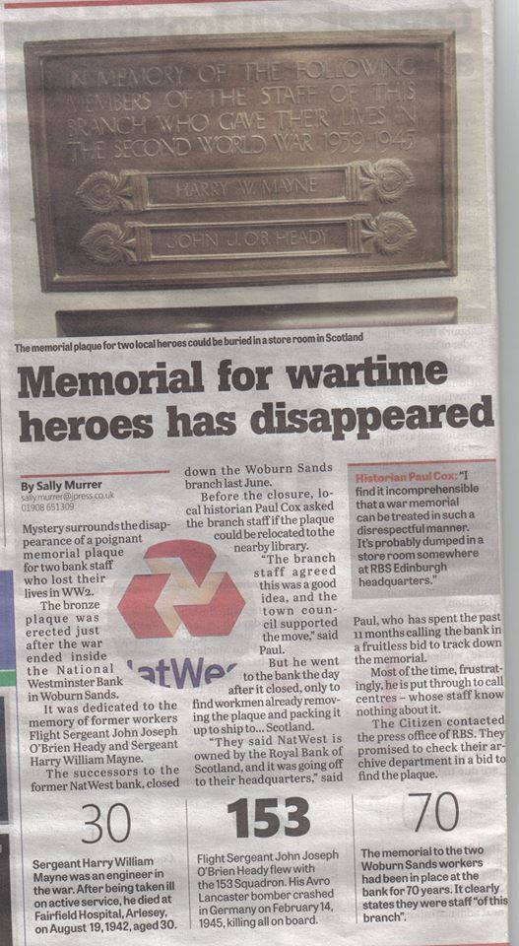

**SNIPPETS**

**Community Market:** The next market will be held on the Memorial Green on Saturday 9 February 10am – 2pm

**Walking for Health**: a new venture started this year is health walks from Woburn car park starting at 10am every Wednesday and lasting initially 30-40 minutes. This is an initiative from Beds Rural communities in conjunction with local surgeries. No charge, no need to book, just turn up and look for Louise.

**300 bus service**: there are a few occasions when the bus driver picking up here just waves people on who show their bus pass card. It is vital that you make sure you swipe the card to register your journey because otherwise the number of people using the service is seen to be declining by Arriva who then use that to further decrease our service**.**

**Water leak:** over the Christmas New year period there was apparently a leak in water pipes to the library which resulted in a bill amounting to over £1000 instead of the usual couple of hundred for the water used as well as an even higher figure for the repair work carried out. There was a hole by the Memorial end of the Library for a few days whilst work was done on the pipes. It appears that insurance companies do not cover for such events.

**Waste Recycling bags:** MKC still provide these free to residents but no longer deliver them automatically every so often to houses. Instead you need to either go on line to MKC website and register, or ring 01908 252570 to order more.

**The Old Fire Station:** Works are due to commence this month to extend the building as part of a refurbishment project and to provide toilet facilities for events held in the Recreation Ground. During this work the car park will be closed for safety reasons.

**Over 60’s Monthly Outings**: The first outing for 2019 will be on Wednesday 20 March then 17April, please look on our website nearer the time for details of destinations.

**Public Convenience** *(picture 4 if room)*

The Town Council currently maintains the Public Convenience on the Memorial Green. It is, however, very costly at just over £12,000 p.a. and we are wondering if it is of real value to the community. Please e.mail / ring the Town Clerk if you have strong views on this.

**Annual Town Meeting and Elections:** In May, local elections will be held and these will include our Town Council. If you would like to consider standing, why not come along to one of our Council meetings on Monday 11 Feb or Monday 11 March at 7.30pm in the Town Council room (down passage at side of the Memorial Hall) to see how we work and come to our Annual Town Meeting on Monday 29 April when we report on the Council’s work over the past year.